Professor Lawrence Goldman

will speak on

'Benjamin Disraeli,

Victorian Statesman: His Jewish and Christian identities’

Wednesday 9th September 2026 from 6.00pm

at Norwich High School for Girls,

95 Newmarket Road, Norwich, NR2 2HU
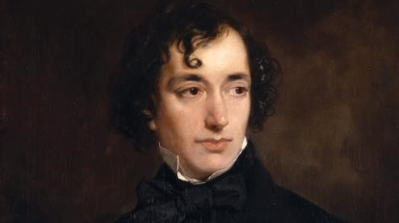

Portrait of the young Disraeli by Benjami Grant,
Hughenden Manor

Benjamin Disraeli was twice British prime minister in the 1860s and 1870s. That he was born Jewish and that his family became Christians is widely known. But many other aspects of Disraeli's religious biography are less clear. This lecture will consider why his family were converted; how and why Disraeli maintained his strong Jewish consciousness; his support for Jewish political causes; the prejudices he faced; and his religious life as a Christian. In short, we shall examine the dual religious identity of Britain's most famous Jew.
Professor Lawrence Goldman is Emeritus Fellow in History, St. Peter's College, Oxford. He was the Editor of the Oxford Dictionary of National Biography and Director of the Institute of Historical Research.

All are welcome!
Entrance is free.

Please contact Mr AC Emerson-Moering via a.emerson@nor.gdst.net if you would like to attend the event.
Thank you.

